**Project II**

Do the following instructions for configuring Standard and Extended ACLs on Router0.

1. **Configure for Standard ACL**
2. Create network topology for Standard ACL and set up IP addresses for each device.

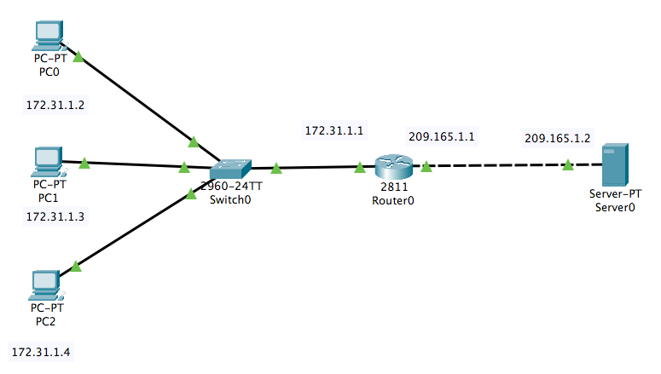

1. Configure Standard ACL on Router0:

Router0(config)#access-list 10 deny host 172.31.1.3

Router0(config)#access-list 10 permit any

Router0(config)#int fa0/0 (check the interface in your network again)

Router0(config-if)#ip access-group 10 in

Router0(config-if)#exit

Router0(config)#exit

1. Try to ping from each PC to server
2. Take screenshots of ping results for PC0, PC1, PC2 to server
3. Submit all screenshots with packet tracer file as Standard ACL
4. **Configure for Extended ACL**
5. Create network topology for Extended ACL and set up IP addresses for each device.



1. Configure Extended ACL on Router0:

Router0(config)#access-list 100 deny ip host 172.31.1.2 host 209.165.1.2

Router0(config)#access-list 100 deny ip host 172.31.1.3 host 209.165.1.2

Router0(config)#access-list 100 permit ip any any

Router0(config)#int fa0/0 (check the interface in your network again)

Router0(config-if)#ip access-group 100 in

Router0(config-if)#exit

Router0(config)#exit

1. Try to ping from each PC to server
2. Take screenshots of ping results for PC0, PC1, PC2 to server
3. Submit all screenshots with packet tracer file as Extended ACL